**DEFECTS -Create, Organize, Sort, Filter, Group, Link Defects**

You can create defect from requirements, test case, test set or defect module.

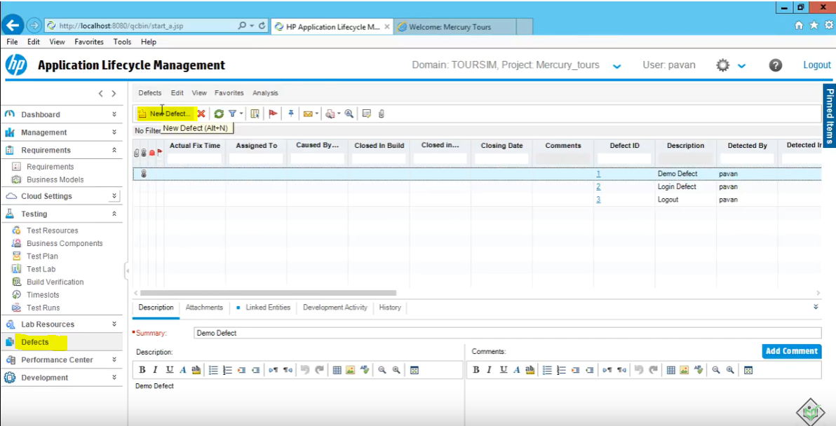

Click on new defect and enter the defect details

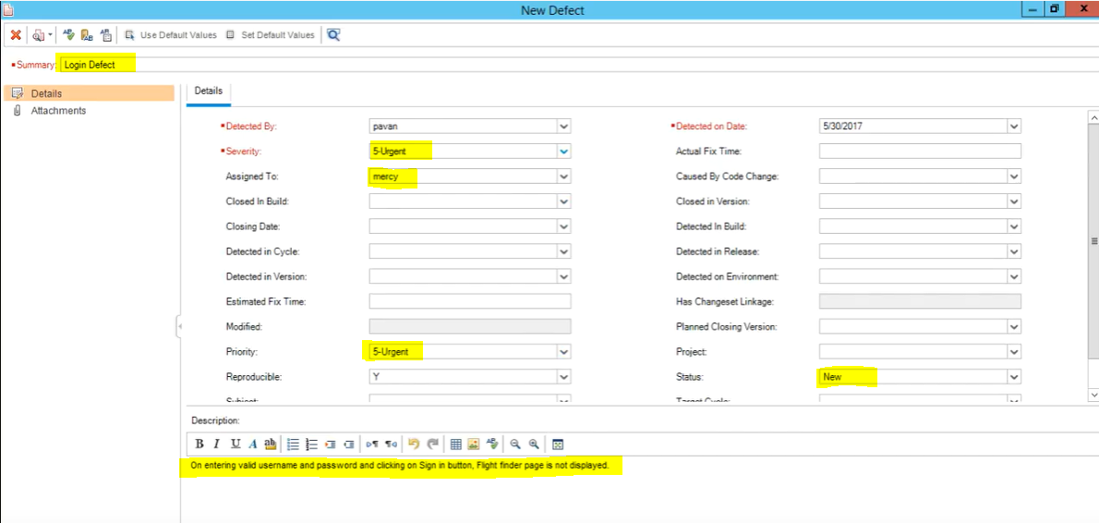

Defect will be listed on defect module

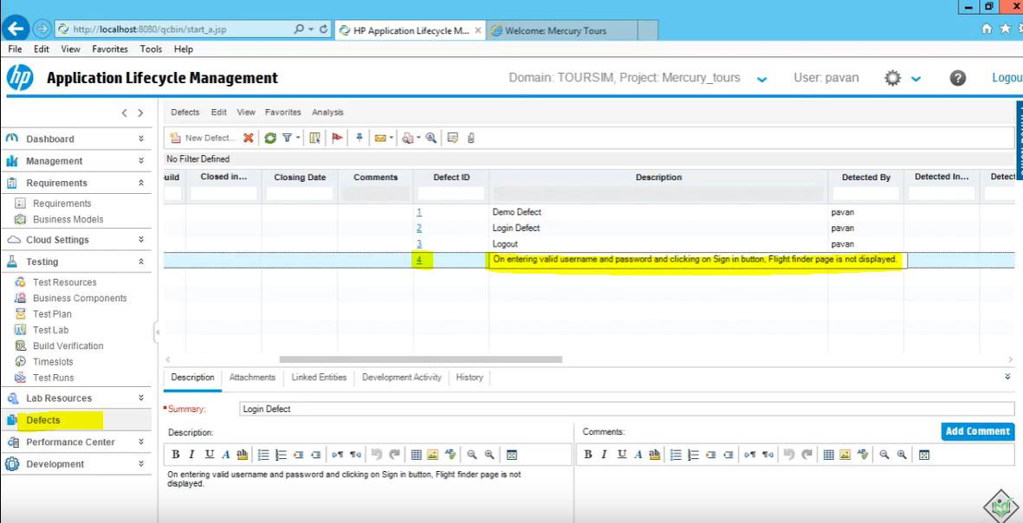

**Organize Defects**

As you can see in defects module, there is all the columns listed and most of them has no data in it. So, to eliminate the columns that we do not need we can remove them form “select column” function

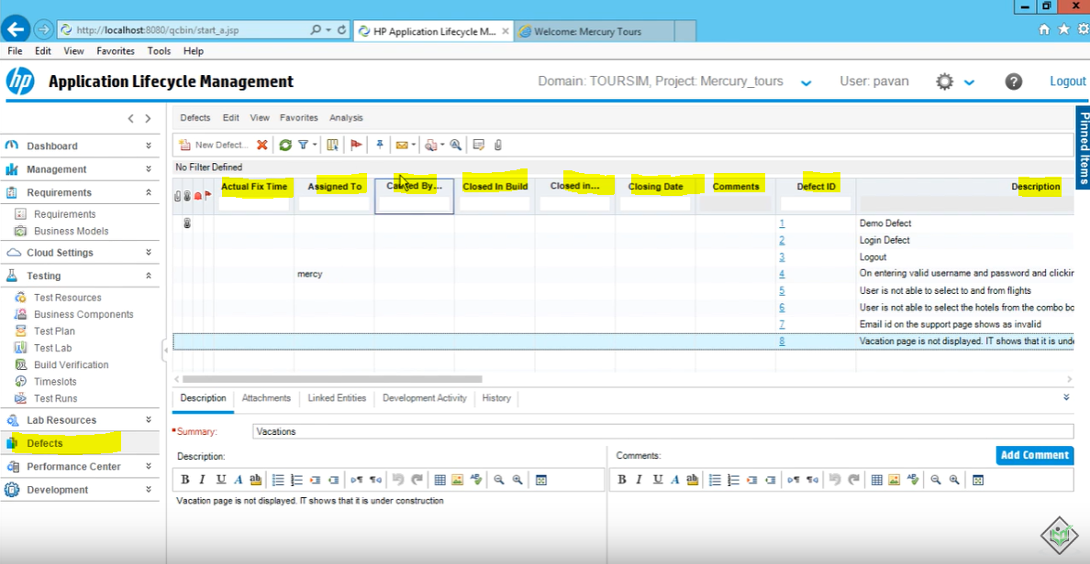

Click on select column and remove the ones not needed

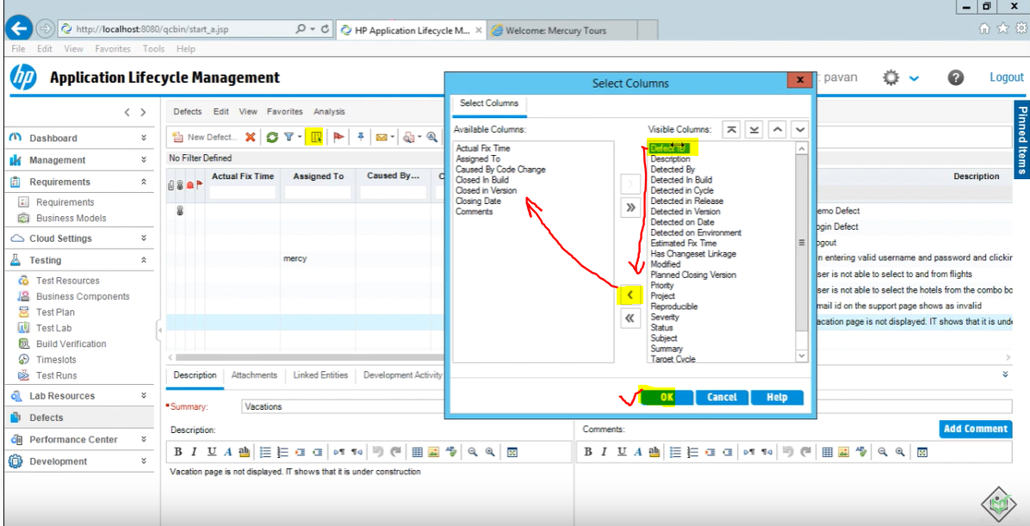

Click on ok

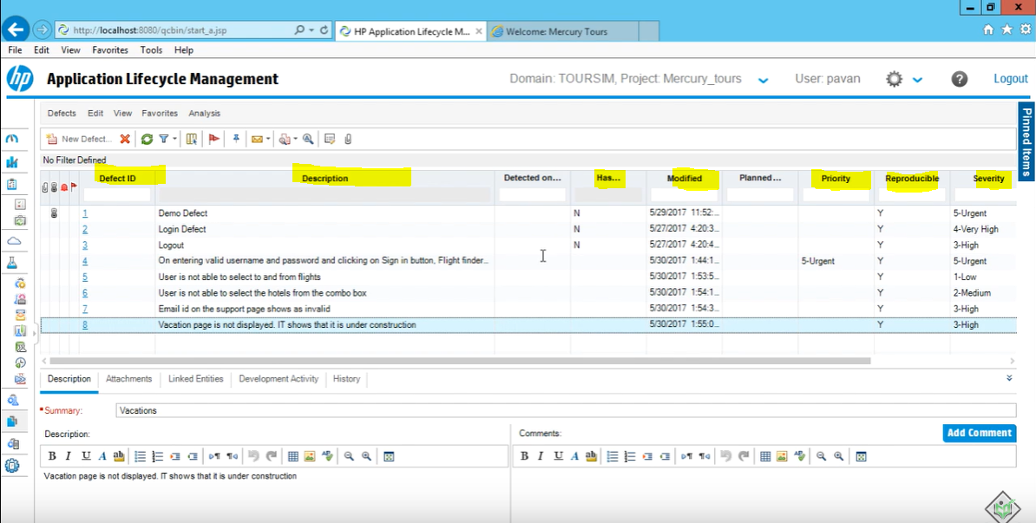

So, we only have the columns we want to see.

We can also move the columns left or right to an order we want to see

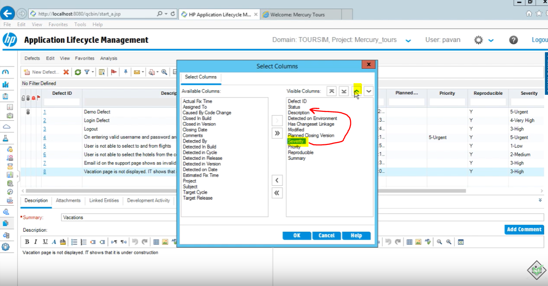

You can also sort filter and group the defects

If you’d like to sort by only one parameter you can just go click on that parameter name and it will be sorting in ascending or descending order

But if you’d like to use more than one parameter to sort and filter then you can go to filter icon and selects filer/sort option

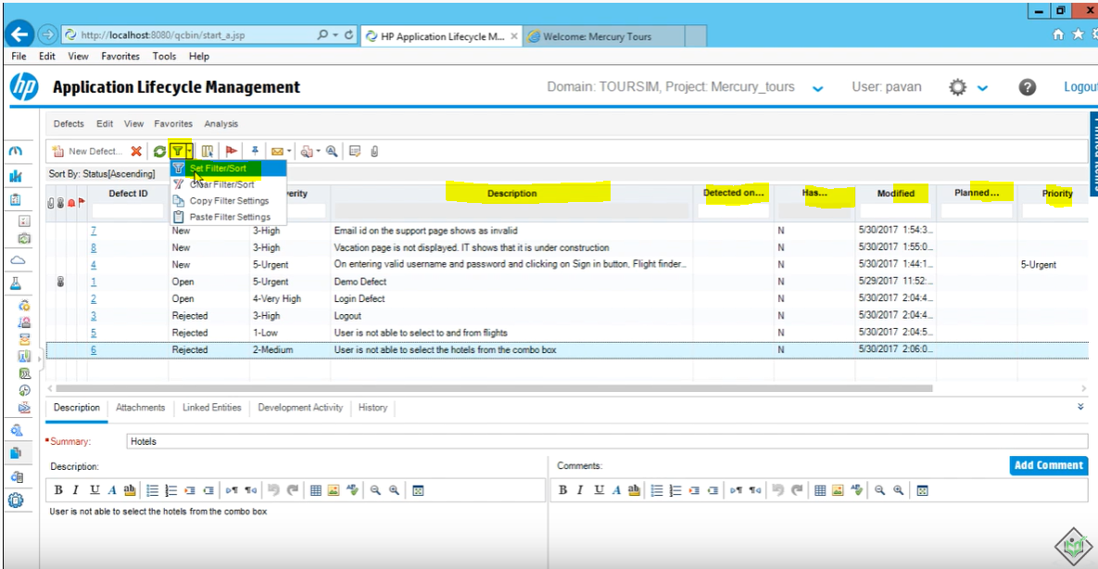

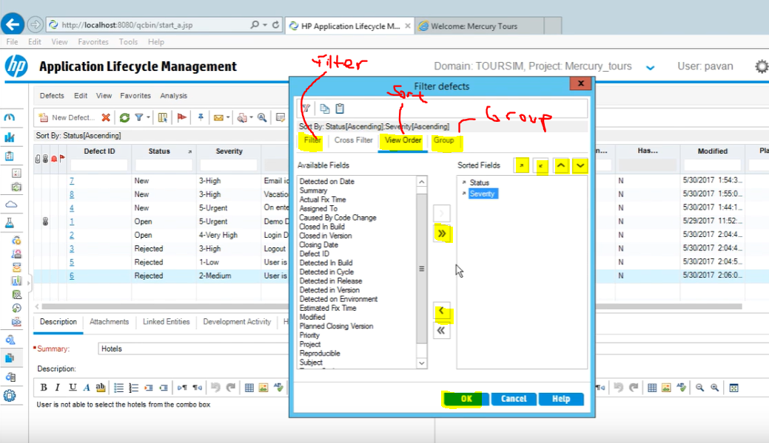

**Grouping the defects**

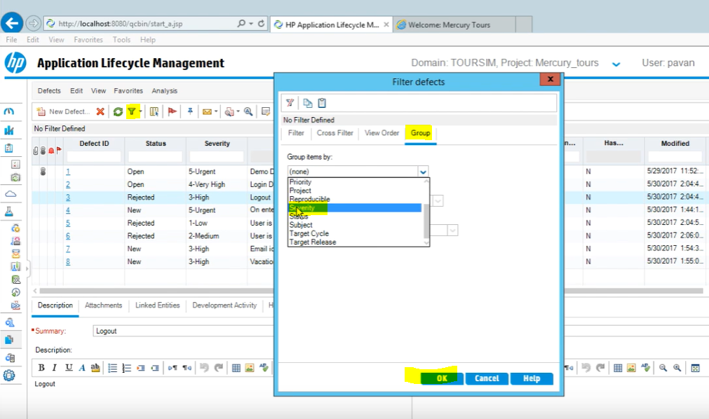

Click ok

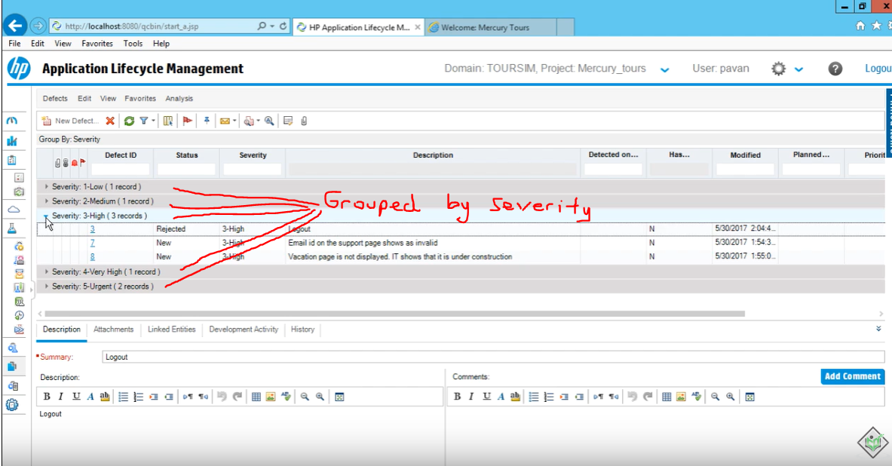

**LINKING DEFECTS**

go to requirement details view

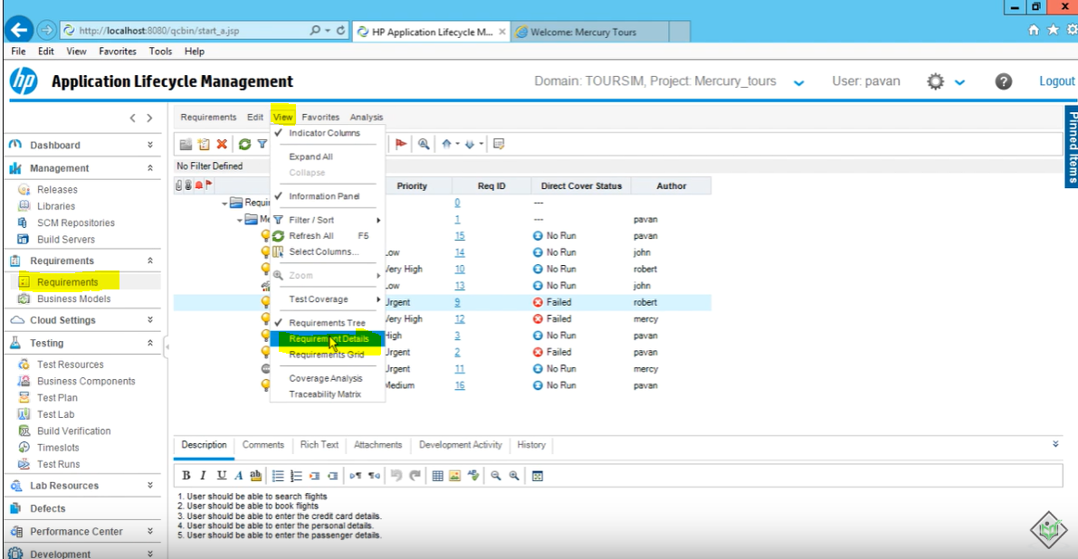

Then select the requirement that you want to link a defect “flight”

Then Click on Linked Defects Tab

Then click on either “add and link defect” or “link existing defect”

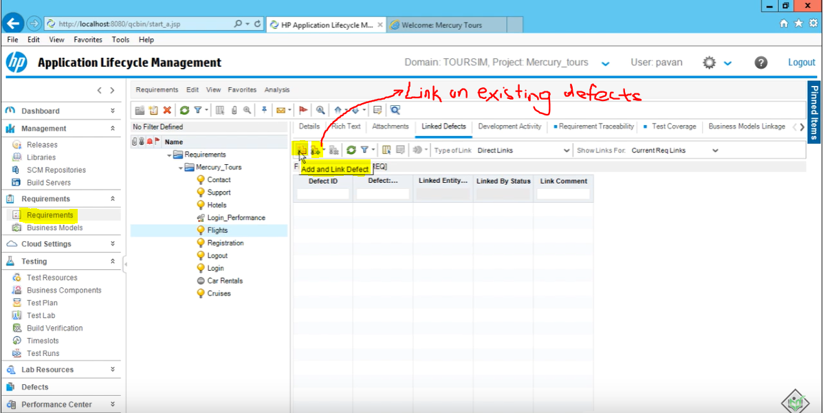

Select the defect and link

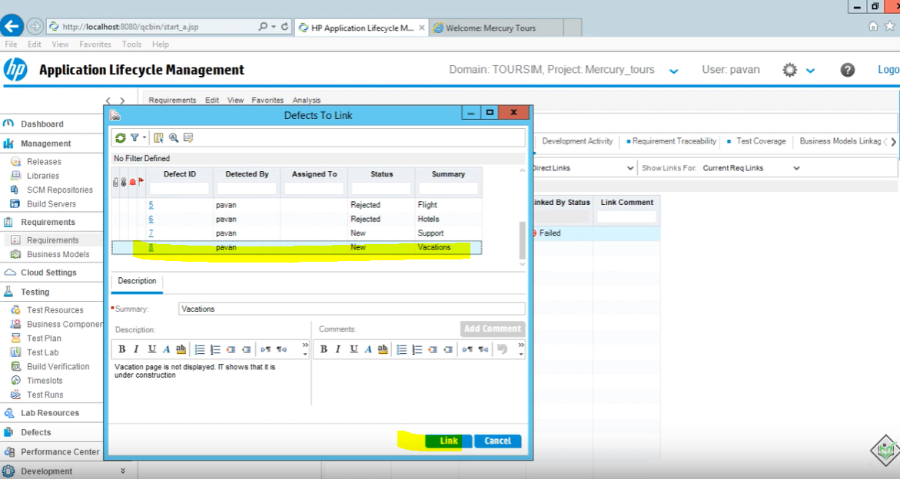

**How to Link a Defect to A Test Plan**

Go to Test Plan module and select “Test Plan Tree View”

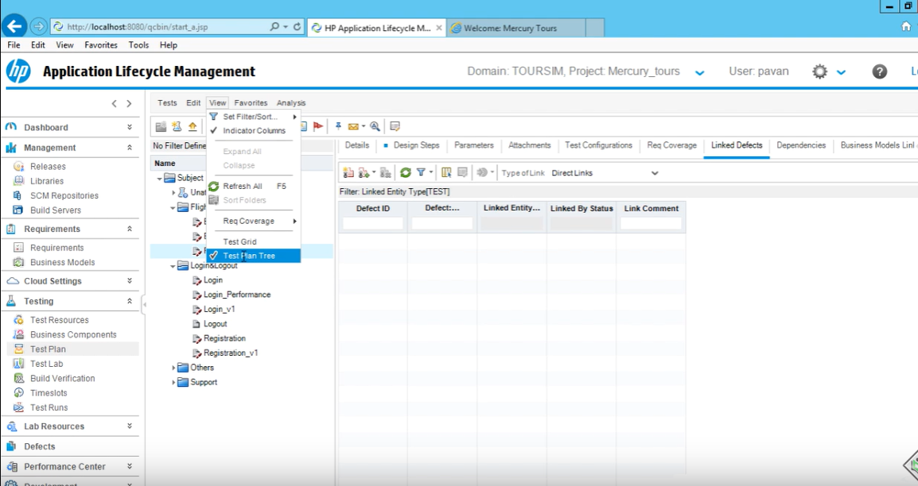

Select the test plan then click on Linked Defects

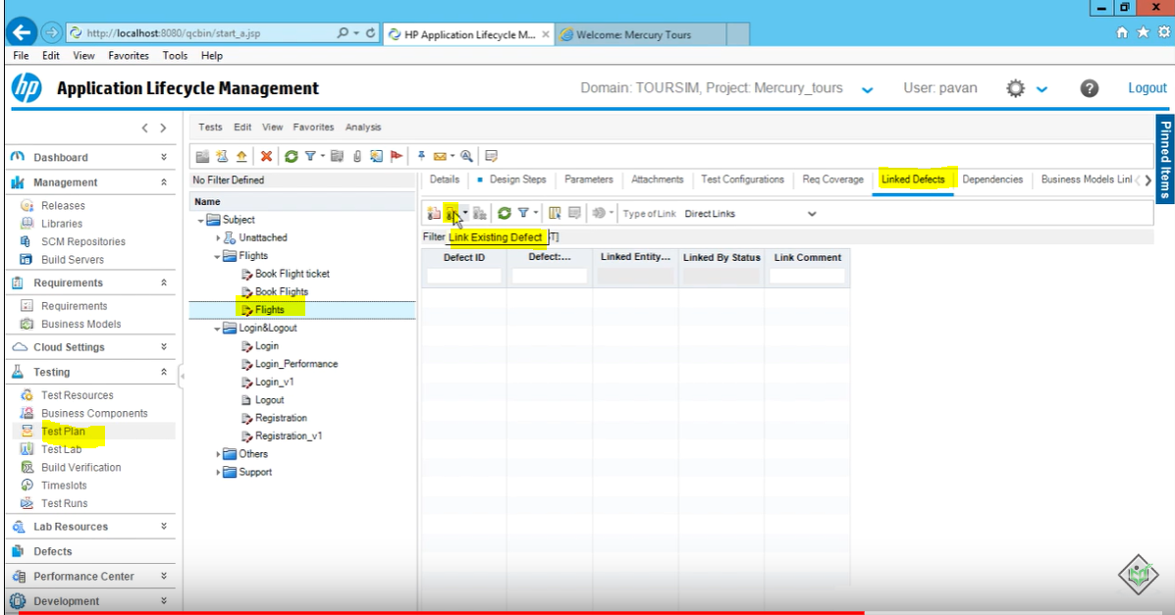

You can also link a defect to Test Set from Test Lab

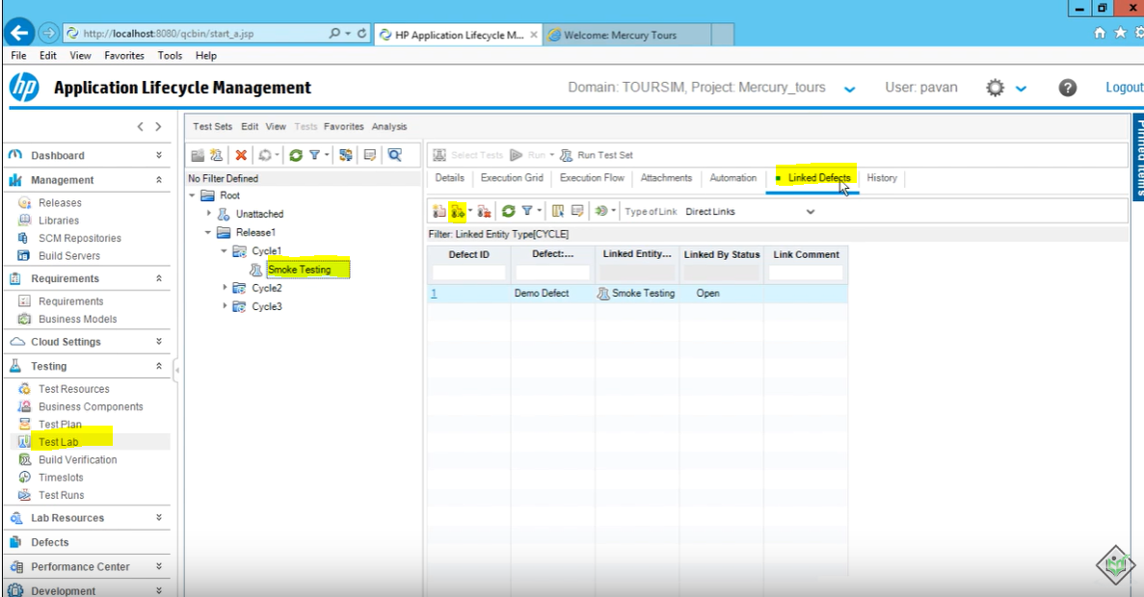

**Linking a Defect to a Test Run**

Open the test run details

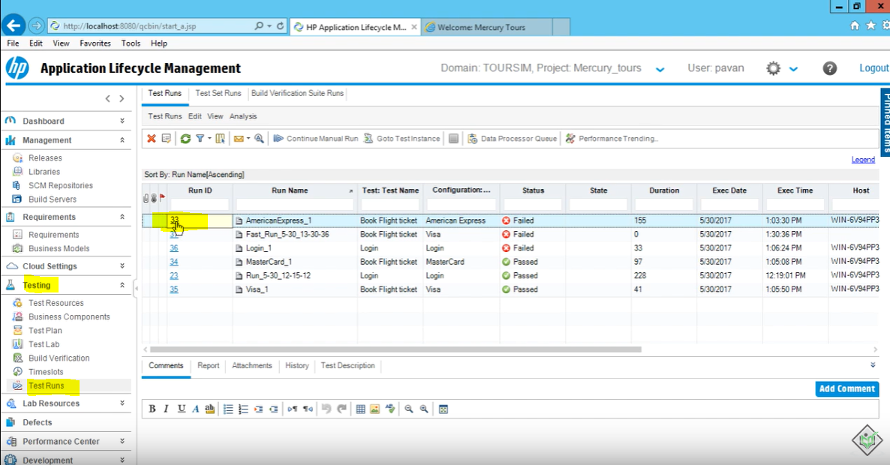

Double click on the test run you want to open

Click on linked defects

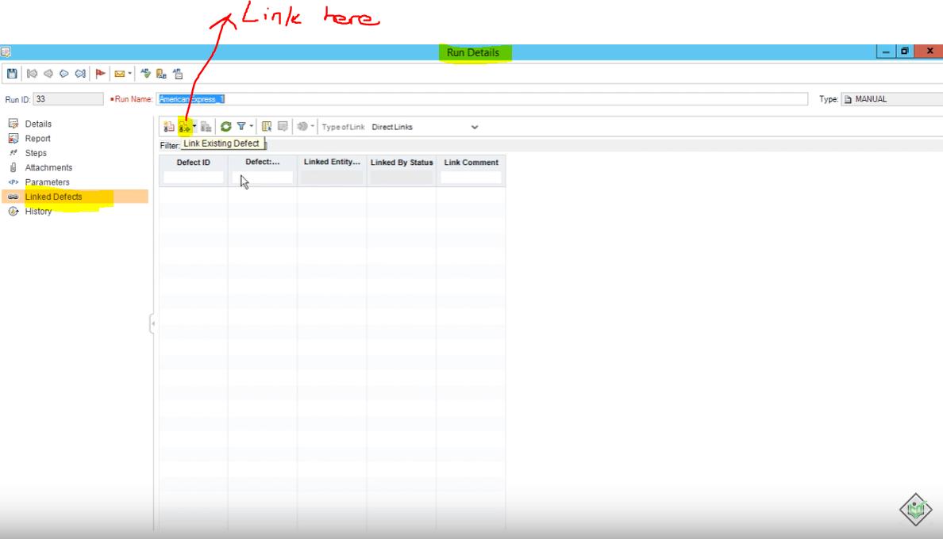

**Link Defects While Execution**

Advantage of linking the defect while the execution is you don’t have to rewrite the description, steps to execute and the expected results automatically will be entered.

Let’s practice running a test case that will fail so that we can add the defect there while execution.

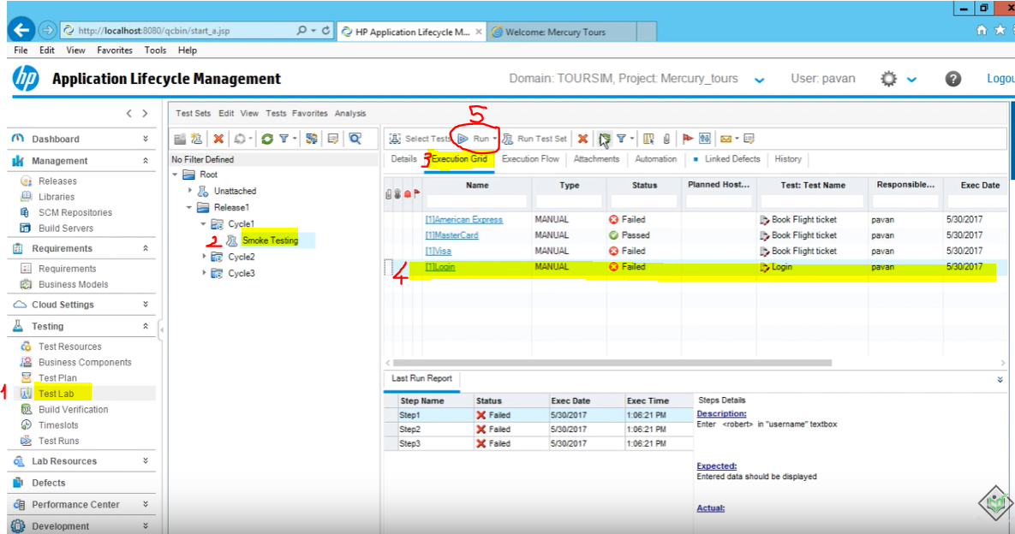

Run with manual runner

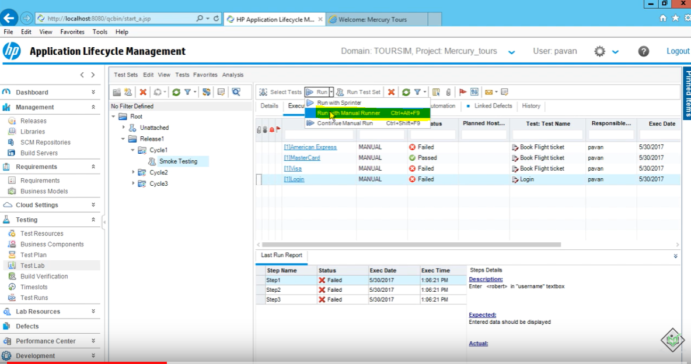

Rename the run

Click on begin run

Enter the actual value for the parameters

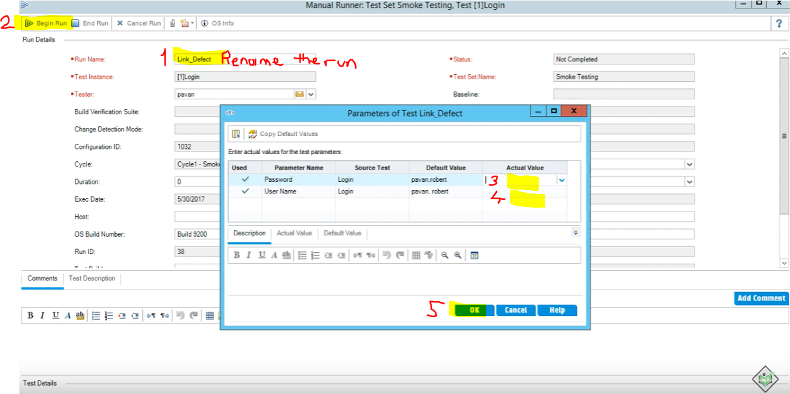

Click ok

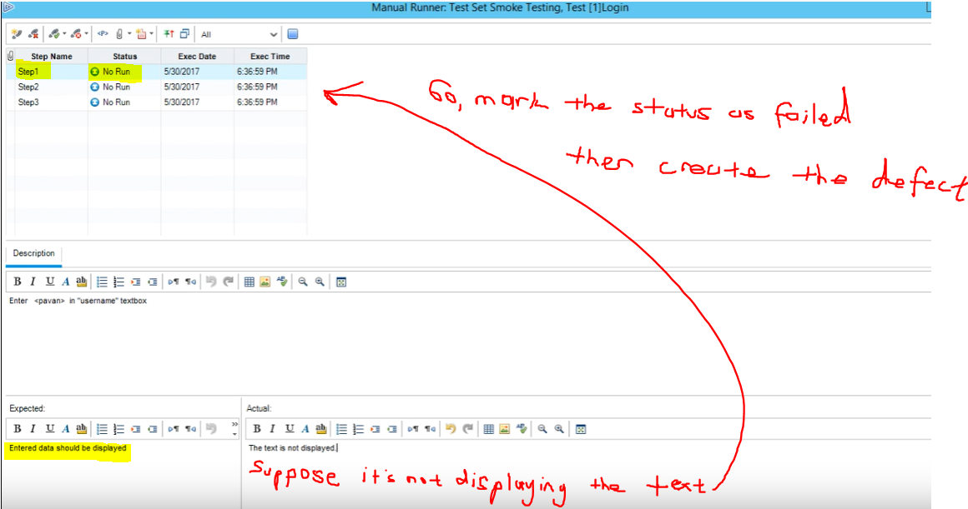

Mark as failed and create a new defect

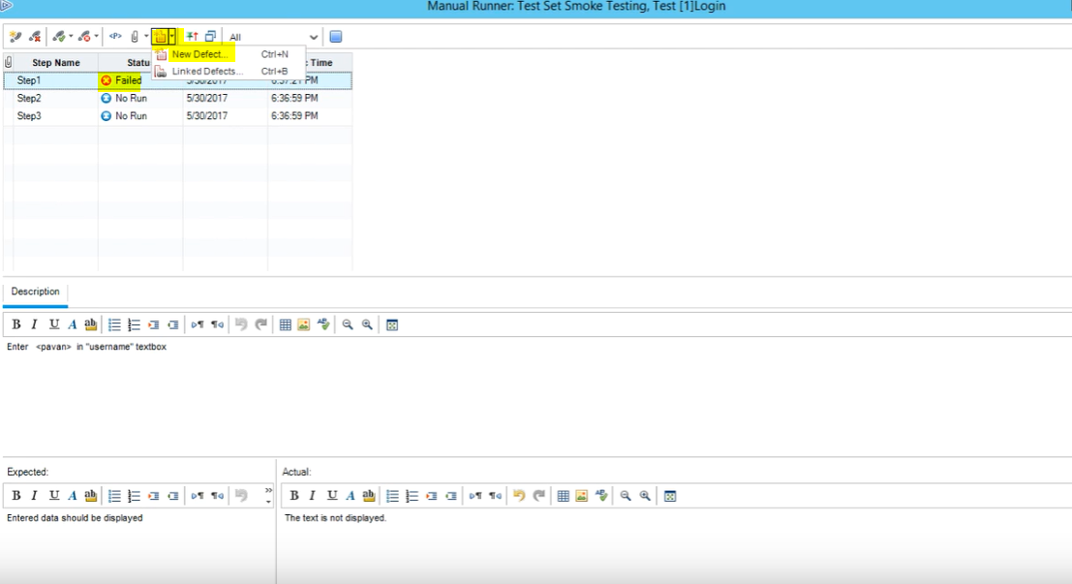

Main part will be entered for you

You just need to select the details such as name, severity etc.

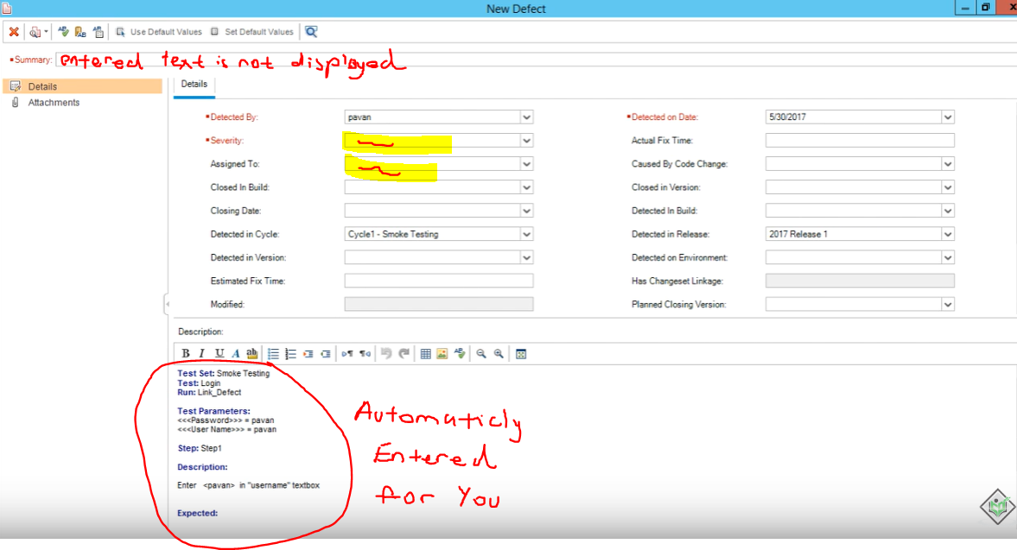

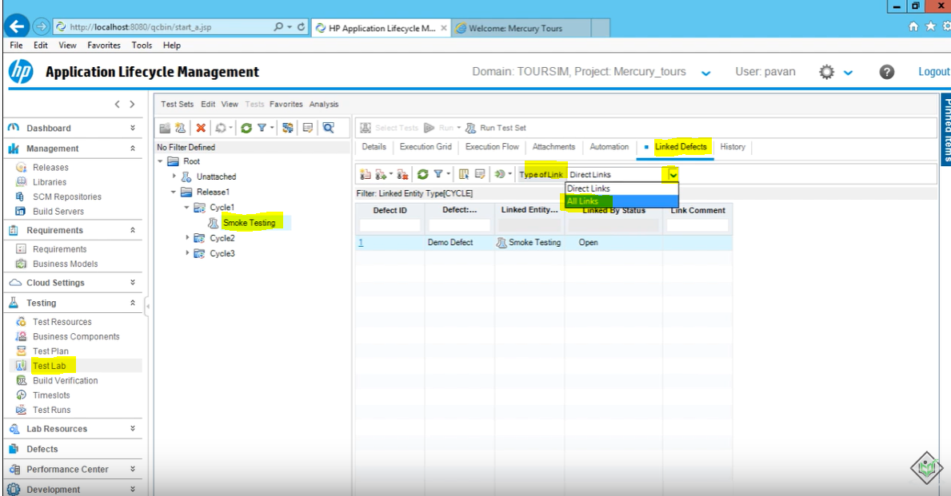

You will be able to see it here

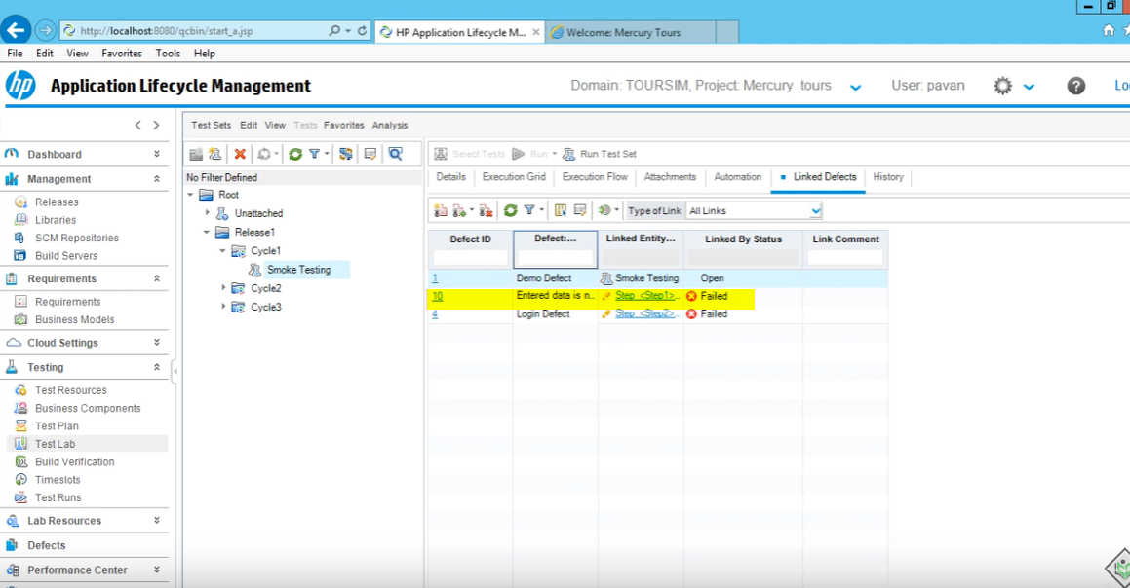

When you link defects to test sets

And if that test set is related to a certain Cycle, under that cycle you will be able to see these defects under that cycle as well

